Alaska Indoor Gardening Curriculum

Salad Container Greenhouse Lesson
Author/Source: Mel Sikes, Alaska Ag in the Classroom

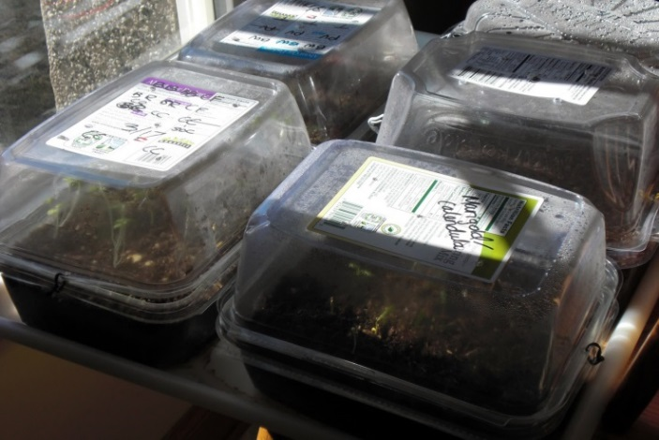
Suggested Grade Levels: 2-8th grade

Time: 45 minutes - 1 hour, follow up & monitoring time

Teaching Goal:
To introduce students how a greenhouse works by making a model using a recycled salad container

Learning Objectives:
To make a model greenhouse and monitor plant growth to see how a greenhouse works.

Core Ideas:
- Plant light and soil nutrient needs
- Standardized Science
- Standardized Science Measurements
- Horticulture
- Germination
- Engineering – Greenhouse Construction and Function
- Recycling
- Plant Life Cycles
- Careers in Agricultural Science
- Standardized Science Measurements
- Recording Scientific Data in Tables
- Light Wave Physics – Types of Light
- Recording Scientific Data in Tables
- Drawing Conclusions from Experimentation

Alaska State Science Standards: 2-LS2-1, 3-LS4-4, 4-LS1-1, 5-PS3-1, 5-LS1-1, 5-LS2-1, MS-LS1-5, MS-ESS3-5
MS-ETS1-2

NGSS Standards: 2-LS2-1, 2-PS1-4, K-2-ETS1-1, 3-LS1-1, 3-LS3-2, 4-LS1-1, 5-PS3-1, 5-LS1-1, 3-5-ETS1-1, MS-LS1-5, MS-LS1-6, MS-LS2-1, MS-LS3-3, MS-ETS1-1

Materials Needed:

- Greenhouse containers – Salad Clamshell Containers without holes are best
- Plant markers – possibly popsicle sticks or plastic spoons/knives
- Potting Soil
- Water and a spray bottle
- Seeds
- Sharpies
- Plant Growth Monitoring Charts

Optional Materials:
- Standardized measuring tools to use as scoops – tablespoons, measuring cups, pint containers, etc.
- A large tub for moistened soil, if you are doing it for the entire class. This is unnecessary if students are doing it for themselves.

- An area to grow the plants

Vocabulary:
- Seedling: a young plant grown from seed
- Germination: Germination is the process by which the seeds begin to grow into the plant.
- Infrared Radiation - Electromagnetic radiation not visible to the eye ("below red" in the visible portion of the spectrum), measured as heat or thermal energy.

Background for Teachers
A greenhouse, also called a glasshouse, is a structure with walls and roof made chiefly of transparent material, such as glass, in which plants requiring regulated climatic conditions are grown. In cooler climates greenhouses are used to control the environment of plants so that they can grow in the season or in an area where they would not normally grow.

A greenhouse works by taking in sunlight and heating it up. This process is the conversion of solar energy, sunlight, to thermal energy, heat. Greenhouses are designed to allow sunlight to filter through the walls and ceiling. The sunlight warms the trapped air inside, creating chemical reactions. These reactions help the plants to grow to their full capacity while protecting them from outside elements. It is a well-known fact that plants grow better when they have temperate heat and a good water source. A greenhouse gives them both.

The composition of a greenhouse is key. Typically, greenhouses are made of plastic or glass. The purpose is to trap as much light and heat as possible, which plastic and glass do. The plants and soil inside absorb all the sunlight and then reflect it back out. As the solar energy is redirected, however, it is changed. Sunlight is composed of shortwave infrared radiation that is able to pass through the greenhouse's exterior. These waves turn into longer-wave infrared radiation after absorption by the plants and they are no longer able to pass through the greenhouse's exterior within the greenhouse. The air that is warmed near the ground is prevented from rising indefinitely and flowing away.

In Alaska we have greenhouses and high tunnels. High tunnels, or hoop houses, are unheated greenhouses that can help commercial farmers extend their growing season so that they can improve the profitability and productivity of their farms. The main difference between a greenhouse and a high tunnel is that in a greenhouse, plants are usually grown in pots on a table while a tunnel has the plants growing right in the ground as they would in a garden. Greenhouses are typically designed to use heaters and powered ventilation systems or evaporative coolers.

Procedure
- Tell the students that today they will be learning about greenhouses. Ask students what a greenhouse is and ask them if they have ever visited one. Ask them to name places where they might find a greenhouse. Possible answers include: at a farm, at a “greenhouse” business like a nursery, a museum, the Pacific Science Center or other museums, etc.

- Discuss how a greenhouse works. Display pictures of different types of greenhouses and high tunnels. Some examples are included at the end of this lesson. Ask the students what they notice about the greenhouses and high tunnels as you display photos. Explain that some plants are placed into greenhouses, because greenhouses help them grow until they can be moved outside.

- Distribute plastic salad containers and lids to all students. This lesson would work well with each student making their own model greenhouse or working in small groups. Consider the space needed for growing and the lighting available in the room before making this decision. Make sure students write their names on the bottom or side of their project with a sharpie.

- Next, the soil needs to be moistened. Model to the entire class how to wet the soil. First, place the approximate amount you’ll need into your tub and model slowly adding water and mixing it in. You may choose to provide measuring cups and standardized measuring tools as scoops so the students continue to develop familiarity with these implements. The soil will be uniformly damp but not soggy or dripping with water when it’s ready. Dixie cups, water bottles, and other containers will work well for groups to use to wet the soil. Consider showing the students what the soil looks like when it’s a little too dry, just right, and too wet. After modeling, have groups retrieve the dry soil from a common area in the room and begin. Alternatively, you can prepare soil for the entire class before or during the lesson. Place all the soil in a large tub and add water slowly, a small amount at a time, and mix until the soil is uniformly damp but not soggy or dripping with water.

- Students will add soil to the container to within one-inch of the top. On seed flats, fill about ½ inch below the top. For the 17 liter tubs add about 4 inches of soil. When you add water, the soil will sink down a little. You don’t want it too shallow – roots need room. Adding water to the soil BEFORE planting assures that the tiny seeds do not all wash into the corner of the tub. Smooth soil flat, sometimes tapping container on a flat surface can help with this process. Be sure to ask the students to check their soil with you and to wait patiently before beginning to plant their seeds. If you are choosing to use a science journal, this is a great time to have students who finish early begin journaling this process. (LINK)

- Show the class the different types of seeds. While students examine them, talk about how the seeds can grow with water and soil, eventually becoming plants. Or, consider teaching the “Reading a Seed Packet” lesson directly before teaching this one. (LINK)

- Sow seeds in rows, spaced according to the packet directions. Label rows of seeds with halved popsicle sticks.

- Consider beginning to close the lesson by having students bring their model greenhouses to you to be checked. If they pass, they can use the class water bottle to water the seeds thoroughly.

- Place in sunny (or grow-lighted location).

- Water weekly or as needed. Monitor seedling growth for the next few weeks. Thin seedlings if necessary to maximize growth. Transplant to larger planters when the seedlings hit the roof of the greenhouse.

Worksheets: Plant Growth Monitoring Chart

Extensions:
- Indoor Lighting Systems Handout (for setting up your system),
- Seed Science Lesson
- Indoor Gardening with Soil Lesson
- Do You Know the Parts of Plants? Lesson
- Individual Plant Parts Lessons
- Reading the Seed Packet Lesson
- Garden Soil Exploration Lesson
- Seedling Transplanting Lesson

Cross Curricular Ideas:
- Ask students to estimate how many seeds they planted in total based on multiplication arrays. How many did a group plant, an individual, the entire class, etc.
- Ask the students how many plants will grow (after doing the above estimation) if 20% of the plants germinate, 50%, 75%, etc.
- Use standardized measuring tools like tablespoons, measuring cups, pint containers, etc. to scoop soil and water and talk about this.
- Explicitly teach the vocabulary including the prefixes, suffixes, and roots of the gardening words
- Read aloud one of the books (ideas below) and use in a reading center
- Expand the journaling prompts into a writing assignment
- Compare and contrast high tunnels with greenhouses as a class or provide additional resources on these systems for students to read and work on independently.
- Have a class discussion on greenhouses and high tunnels and why they may be a valuable tool for Alaskan farmers and gardeners. Discuss who would benefit more, a farmer in Fairbanks or a farmer in Metlakatla?

Assessment Options:
- Observe students over the course of the project, and keep the following questions in mind: Did students understand the meaning of the word "greenhouse"? Did they show curiosity about the seeds and how they will grow? Did they concentrate during the project and work well independently? Consider developing this into a checklist to mark as you observe the students working.
- Develop the lesson into a science journal page.
- Consider having students sketch a finished model of the greenhouse including a representation of the solar energy inside and outside the structure.
- Ask students to pretend to be a gardener or farmer in their area who needs to convince a bank, relative, or native corporation to fund a greenhouse for their small business. Why would a greenhouse help them? Evaluate the paragraph.
Resources:
Books:
From Seed to Plant by Gail Gibbons
ISBN: 0-8234-1025-0 1991

How a Seed Grows by Helene J. Jordan, illustrated by Loretta Krupinski
ISBN-13: 978-0-06-445107-9; ISBN-10: 0-06-445107-0

Websites:
Greenhouse info for kids
https://wiki.kidzsearch.com/wiki/Greenhouse

How Greenhouses work:
http://garden.lovetoknow.com/wiki/How_Does_a_Greenhouse_Work

High Tunnel Information
http://hightunnels.org/
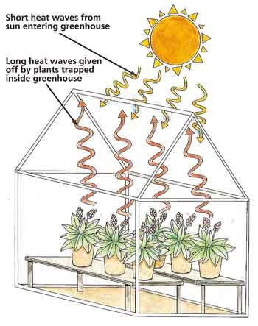

Greenhouses

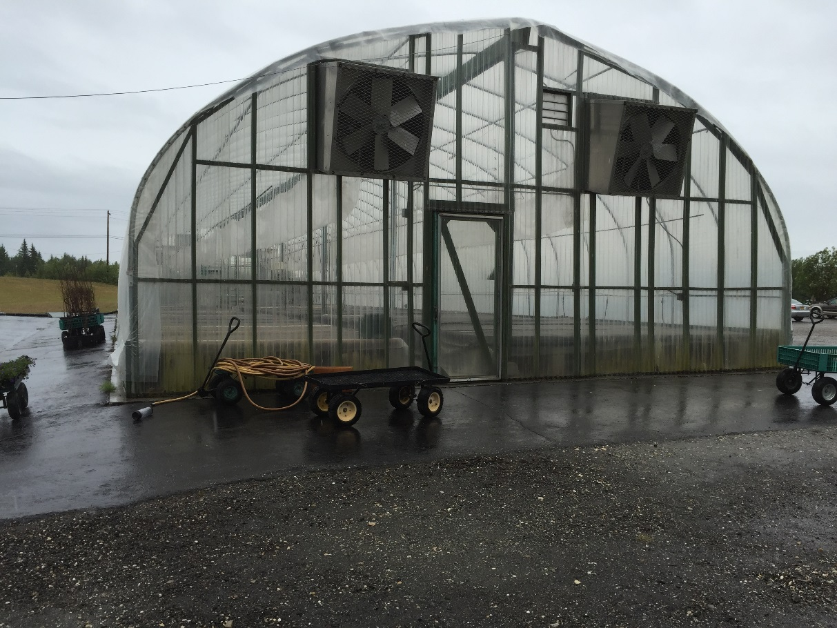

Greenhouse at Plant Kingdom in Fairbanks

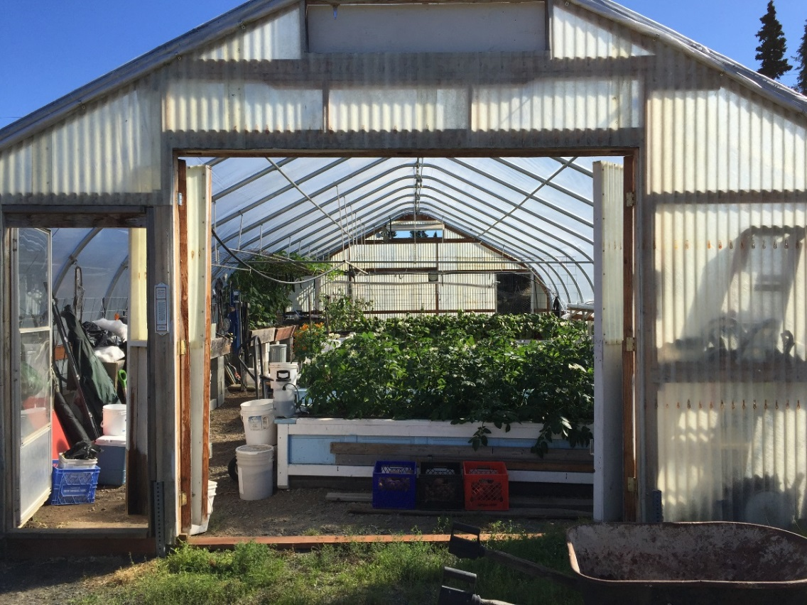

Greenhouse in Kenai
High Tunnel
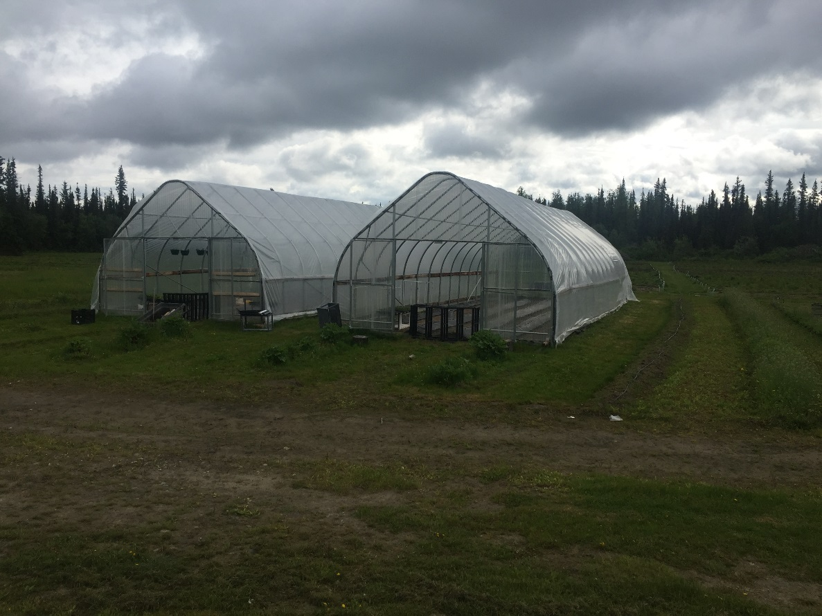

High Tunnels on Eielson Farm Road in North Pole
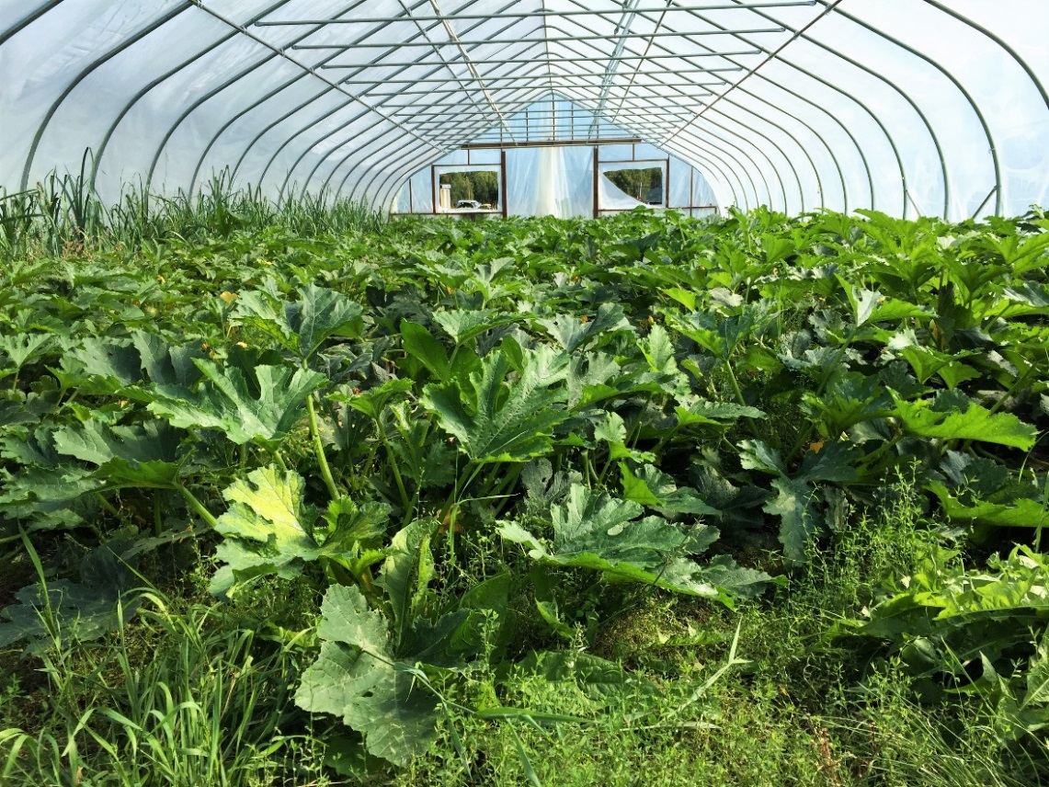

High Tunnel in Kasilof
